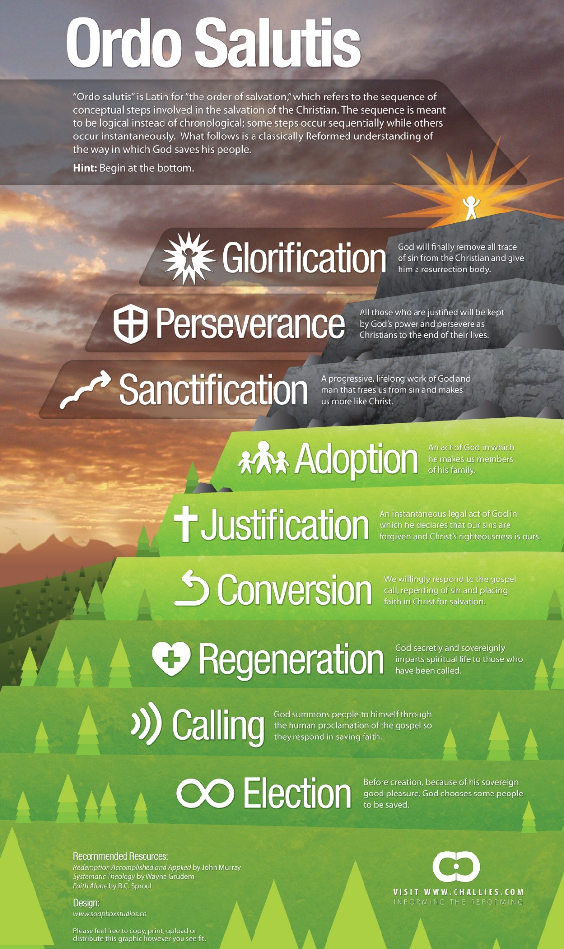
Augustine: “Incomprehensible and immutable is the love of God. For it was not after we were reconciled to him by the blood of his Son that he began to love us, but he loved us before the foundation of the world, that with his only begotten Son we too might be sons of God before we were anything at all.”

Harvest Constitution: We believe that, “God so loved the world that He gave his one and only Son, that whoever believes in Him shall not perish, but have eternal life” (John 3:16). We believe that Jesus Christ died for our sins according to the Scriptures, as a representative and substitutionary sacrifice. We believe that each person who receives, by faith, Jesus Christ as Savior and Lord has been born again of the Holy Spirit and, therefore, becomes eternally secure as a child of God. We believe that justification means that a person is declared righteous in the sight of God by grace alone, through faith alone, in Christ alone, apart from man's works. We believe the Holy Spirit baptizes each believing person into the body of Christ at the moment of salvation once and for all. John 1:12; Romans 3:21-26; 8:37-39; 1 Corinthians 12:13; 2 Corinthians 5:21; Ephesians 1:13; 2:8-10

Union with Christ overarches every aspect of salvation (Eph 1:3).
- We were elected in Christ (Eph 1:4; 2 Tim 1:9).
- We are called into fellowship with Christ (1 Cor 1:9; 1 Jn 1:3; Phil 3:8, 10).
- We are regenerated in Christ (1 Jn 5:11; Eph 2:10).
- We believe in Christ (Jn 3:16).
- We are justified through our union with Christ (Rom 8:1; 2 Cor 5:21) in his life (Rom 5:19), death (1 Pet 2:24; Rom 6:5a), burial (Col 2:12), resurrection (Eph 2:5; Rom 6:5b), and ascension (Eph 2:6).
- In Christ we are redeemed from sin (Rom 3:24; 1 Cor 1:30; Gal 3:13; Eph 1:7) and we have peace with God (“reconciliation” – Rom 5:1, 10-11; 2 Cor 5:18-20; Col 1:21-22).
- We are united with other believers as one body in Christ (1 Cor 12:13; Rom 12:5; Jn 17:21; Gal 3:28).
- We are sanctified in the reality of our union with Christ (Rom 6:4, 11; Gal 2:20), becoming more like Christ (Rom 8:29; Eph 4:13).
- Our actions should be in Christ (Phil 4:13; 1 Cor 15:58; Jn 15:5) and in imitation of Christ (1 Jn 2:6; 1 Pet 2:21), even to the point of suffering (Phil 3:10; Heb 13:13).
- Christ never leaves us (Mt 28:20).
- We will die in Christ (Rev 14:13), our bodies will be raised in Christ (1 Cor 15:22), and we will be glorified in Christ (Rom 8:17).

Election
Before the creation of the world (Eph 1:4-5; 2 Thess 2:13; Rev 13:8), God freely ____________ (1 Thess 1:4; 1 Pet 1:1) certain ____________________ (Rom 11:7) to be saved (Acts 13:48; Rom 8:28-30).
- This choosing was ____________, not based on any foreseen merit in those individuals, but only because of God’s loving will (Rom 9:11, 15; 11:5-6; 2 Tim 1:9; Eph 1:5).
  - Election is sometimes called “_________________” (Rom 8:29), referring to God’s initiating a relationship with an individual (1 Cor 8:3; Gal 4:9; 2 Tim 2:19; Jn 10:27) before they were born.
- The truth of election is intended to be a comfort (Rom 8:28-30), a reason to praise God (Eph 1:4-6; 2 Thess 2:13), and a motivation for _____________________ (2 Tim 2:10; Acts 18:10-11).
  - The truth of election is in no way intended to negate man’s _______________ (Mt 11:28; Jn 3:18; 5:40; Rev 22:17; Rom 10:14) or to deny God’s ____________ for all men (Ezek 33:11; Mt 23:37; 1 Tim 2:4; 2 Pet 3:9).

Calling: The proclamation of the ______________ of Christ (2 Thess 2:14; Rom 10:14; Acts 3:19; 16:14)
- In general calling, God ____________ all men without distinction to salvation (Mt 22:14; Acts 17:30; Rev 3:20; 22:17).
- In effectual calling, God ______________ the elect to salvation (Jn 6:37; Rom 8:30; 1 Pet 2:9; 1 Cor 1:9; 1 Thess 2:12).

Regeneration is an instantaneous act of God (Jn 1:13; Jms 1:18) whereby he imparts spiritual ____________ to spiritually dead individuals (Jn 3:3-8; Eph 2:1, 5; Col 2:13).
- Regeneration affects one’s entire being (2 Cor 5:17). It results in immediate saving ________________ (Acts 16:14; 1 Jn 5:1; Jn 3:5) and a changed ________________ (1 Jn 2:29; 3:9; 4:7; 5:4).

Conversion is a simultaneous turning ____________ sin in repentance and turning __________ Christ in faith (Acts 20:21; 26:18; Heb 6:1; 1 Thess 1:9).
- Saving _____________ includes a genuine sorrow for sin and a sincere renouncing of it (2 Cor 7:9-10; Lk 24:47; Acts 2:38; 3:19).
- Saving _____________ includes knowledge of Christ and his gospel (Rom 10:14) and a willing trust in the person of Christ for forgiveness and eternal life (Jn 1:12; 3:16; 6:37; Eph 2:8; Rom 3:22).
A regenerated individual will ____________ in an attitude of repentance (Mt 6:12; Rev 3:19) and faith (Gal 2:20; Col 1:23) throughout his life.

Justification is God ___________ declaring (Rom 8:1, 33-34) undeserving sinners (Rom 3:23-24) as ____________, solely on the basis of Christ’s life and death (Rom 5:19; 1 Cor 1:30; Phil 3:9).
- Justification is by ______ alone, not by works (Rom 3:24; 4:4-6, 16; Gal 2:16; Eph 2:8-9).

Adoption is an act of God whereby he makes believers members of his ______________.
- Believers are God’s ____________ (Rom 8:14; Gal 4:5; 1 Jn 3:1-2), with all the attendant benefits (Rom 8:15-17; Gal 4:6-7; Mt 6:9, 32; 7:11; Heb 12:6, 10) and responsibilities (Eph 5:1; 1 Pet 1:14-16; Mt 5:16; Phil 2:15; 1 Jn 3:10).
- Believers are also, in a sense, Jesus’ younger siblings (Heb 2:11-12; Rom 8:29).
- Believers are members of God’s family, the ____________ (1 Tim 5:1-2; fellow believers are called “brothers” over 100x in the epistles).

Redemption (Col 1:14)

Reconciliation (Rom 5:10; 2 Cor 5:18-20)

Sanctification is the ____________ by which believers become more like Christ throughout life.
- It is a progressive (2 Cor 3:18; Phil 3:12-14) work of both ________________ (Phil 2:13; 1 Thess 5:23; Heb 13:20-21) & _______________ (Rom 6:11-13; 8:13; Phil 2:12; 3:12-14; Heb 12:1, 14; 2 Cor 7:1).
- ______________ in sanctification include Scripture (Jn 17:17), prayer (Eph 6:18), worship (Eph 5:18-20), fellowship with believers (Heb 3:13; 10:24-25; Eph 4:16), self-control (Titus 2:12), and hope (Col 1:4-5; 1 Pet 1:13).
- Believers are ____________ sanctified at the moment of regeneration (1 Cor 1:30; 6:11; Rom 6:14, 18), but the process of sanctification is not fully completed until death (1 Jn 1:8; Prov 20:9; Mt 6:12; Jms 3:2; Heb 12:23).

Perseverance
All those who are ____________ regenerated will be kept by God (Jn 3:36; 6:39-40; 10:27-29; Rom 8:30; Eph 1:13-14; Phil 1:6) and will persevere in faith (1 Pet 1:5; Col 1:23) and growth (Jms 2:14-26; 1 Jn 4:6; 2 Pet 1:5-10; Eph 2:10) until the __________ of life (Mt 10:22; Heb 3:14).
- Professing believers who show external _________________ of conversion but finally fall away demonstrate that they were never truly regenerated (1 Jn 2:19; Mt 7:21-23; Jn 15:2, 6; 17:12; Heb 6:4-6).

Glorification: God fully and finally eliminates the power and presence of ___________ from the believer, completing his transformation into the ________ of Christ (Rom 8:29-30; Phil 3:20-21).

Recommended Reading:
John Murray, Redemption: Accomplished and Applied
John MacArthur, The Gospel According to Jesus
John Piper, Finally Alive
Jerry Bridges, The Discipline of Grace: God’s Role and Our Role in the Pursuit of Holiness

